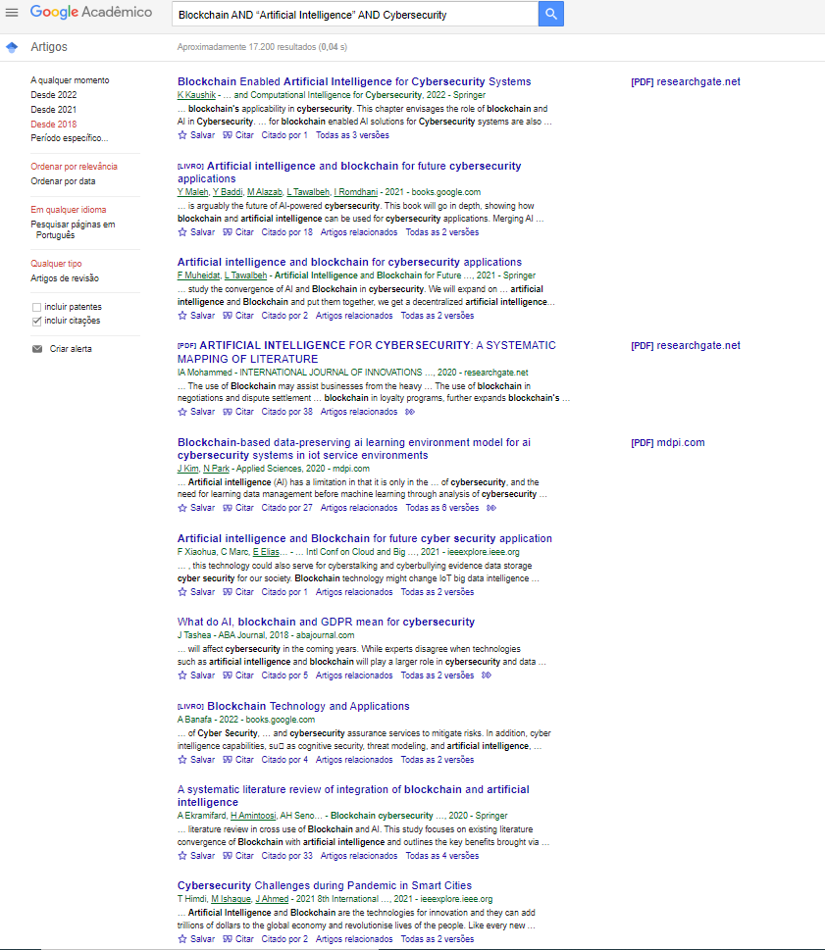

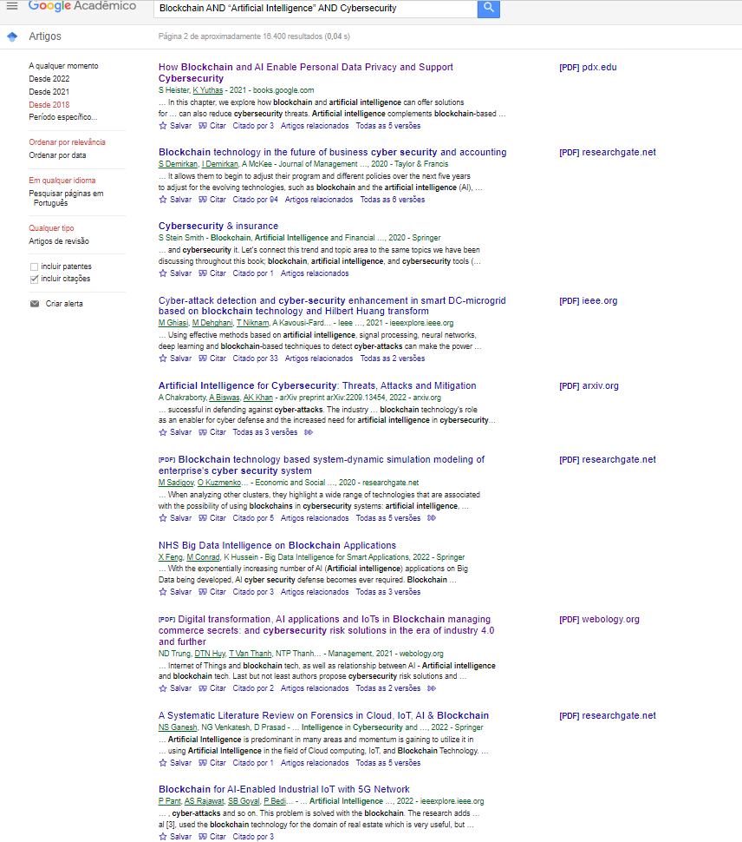

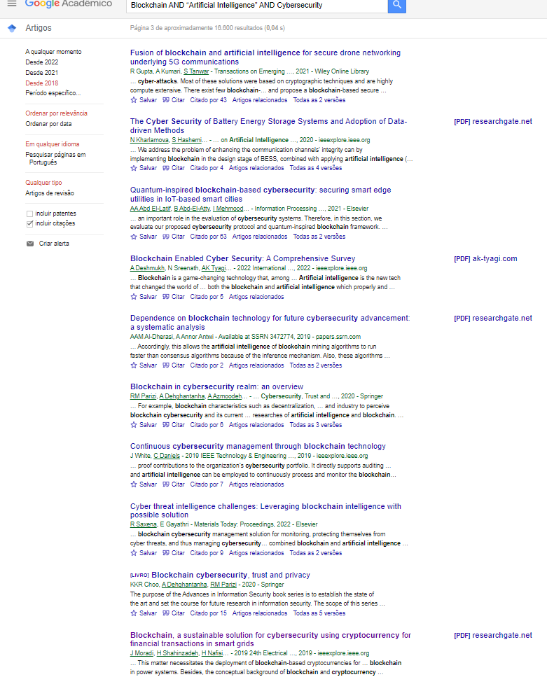

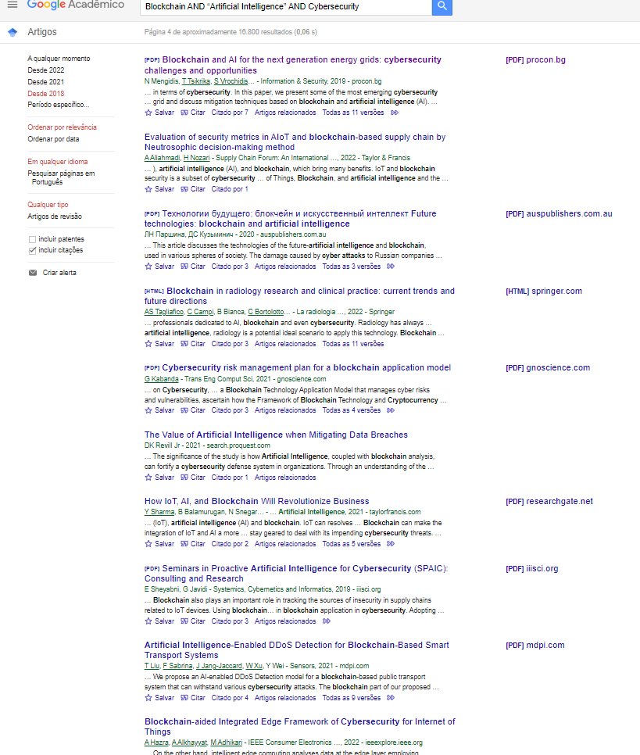

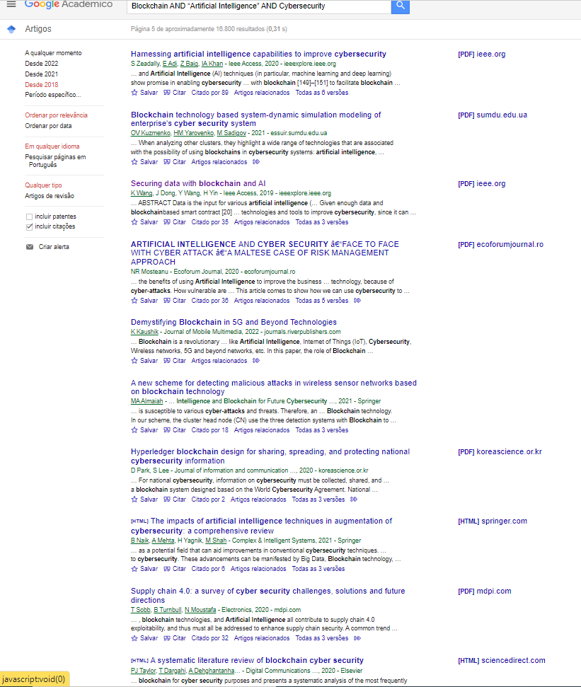

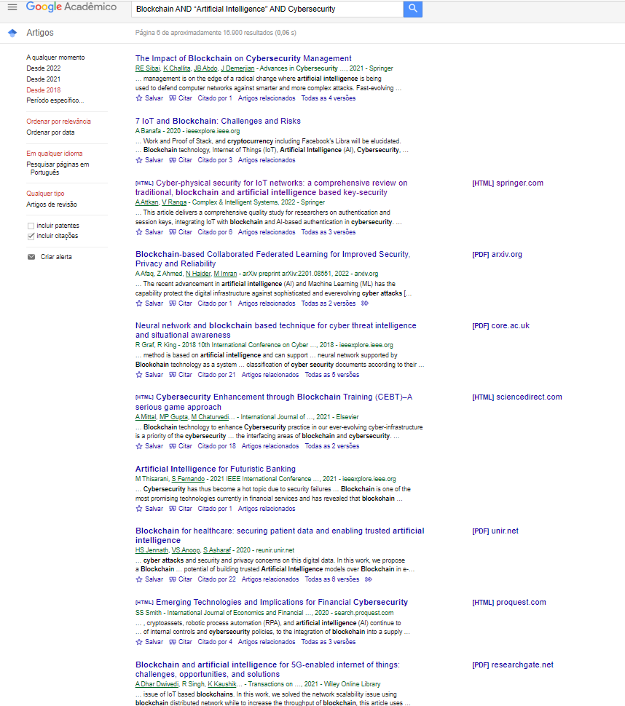

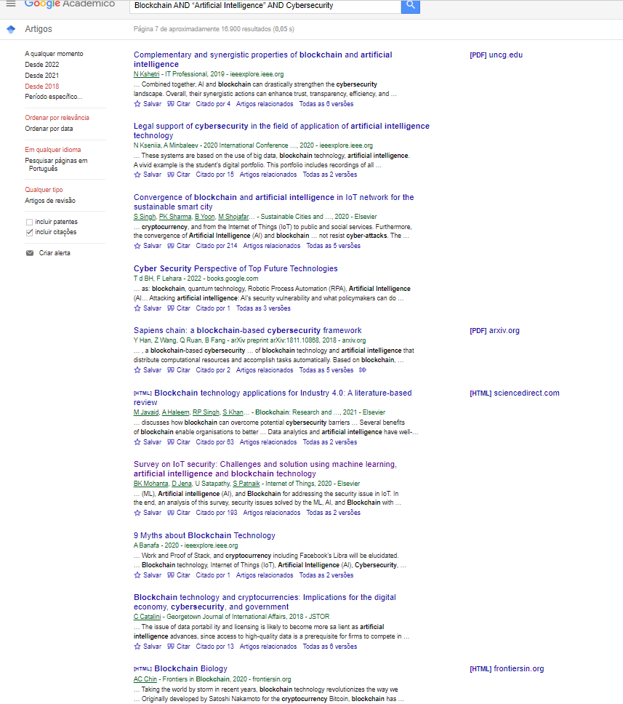

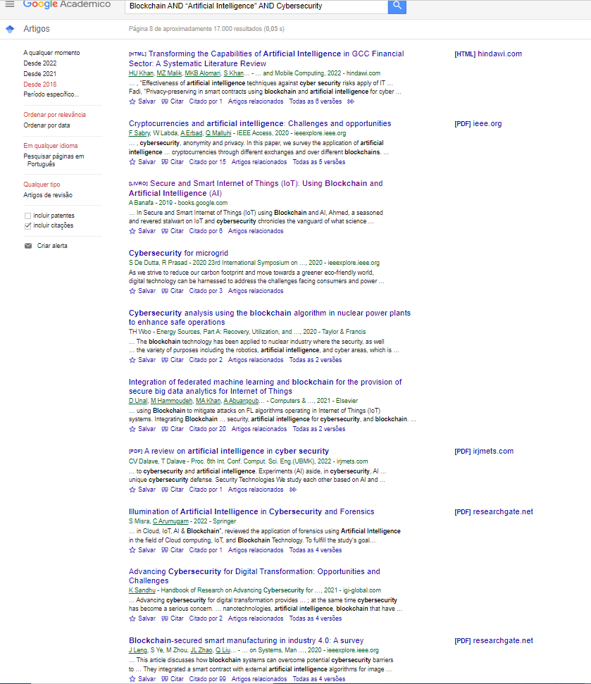

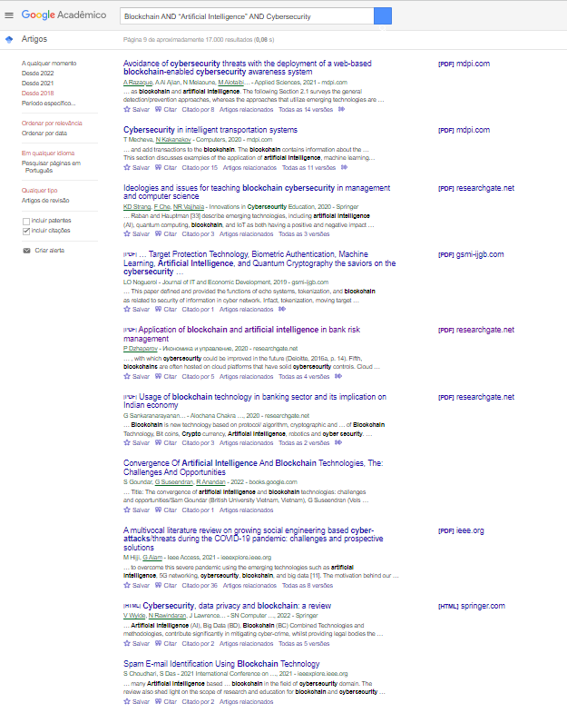

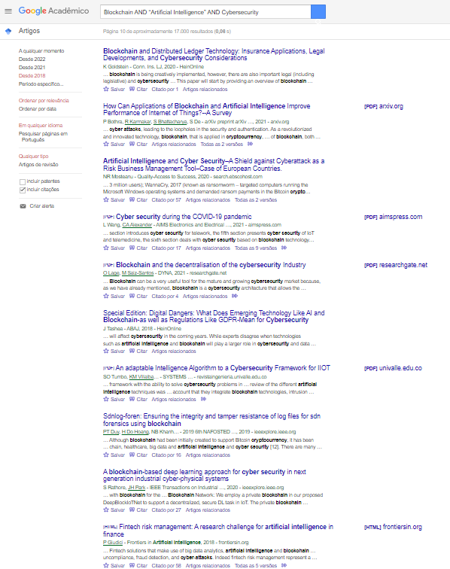

**Aplicações Futuras:**

<https://link.springer.com/chapter/10.1007/978-3-030-74575-2_1>

<https://ieeexplore.ieee.org/abstract/document/9730163>

<https://procon.bg/ru/system/files/4302-blockchain_ai_energy_grids.pdf>

**Bancos e Instituições Financeiras:**

https://www.researchgate.net/profile/Plamen-Dzhaparov/publication/341940501_APPLICATION_OF_BLOCKCHAIN_AND_ARTIFICIAL_INTELLIGENCE_IN_BANK_RISK_MANAGEMENT/links/5eda508b299bf1c67d41d0ea/APPLICATION-OF-BLOCKCHAIN-AND-ARTIFICIAL-INTELLIGENCE-IN-BANK-RISK-MANAGEMENT.pdf

**Sistemas:**  
<https://link.springer.com/chapter/10.1007/978-3-031-05752-6_11>

<https://www.mdpi.com/2076-3417/10/14/4718>

<https://books.google.com.br/books?hl=pt-BR&lr=&id=Y7ZaEAAAQBAJ&oi=fnd&pg=PA33&dq=Blockchain+AND+%E2%80%9CArtificial+Intelligence%E2%80%9D+AND+Cybersecurity&ots=HMDsVZspfv&sig=97hytAlUmH_bT33TRLuwrpXgraY#v=onepage&q&f=false>

<https://www.webology.org/data-cms/articles/20211101123851pmWEB18140.pdf>

<https://ieeexplore.ieee.org/abstract/document/8733072>

<https://www.sciencedirect.com/science/article/abs/pii/S2542660520300603>

<https://books.google.com.br/books?hl=pt-BR&lr=&id=L1OIDwAAQBAJ&oi=fnd&pg=PT14&dq=Blockchain+AND+%E2%80%9CArtificial+Intelligence%E2%80%9D+AND+Cybersecurity&ots=tGF_gRwlNq&sig=EOldx0FhJGMK6pZm4dzapPaauN0#v=onepage&q=Blockchain%20AND%20%E2%80%9CArtificial%20Intelligence%E2%80%9D%20AND%20Cybersecurity&f=false>

**Outras Aplicações:**<https://onlinelibrary.wiley.com/doi/epdf/10.1002/ett.4176>

<https://link.springer.com/article/10.1007/s40747-022-00667-z>

13 de 100